Physics 30 Lesson 36 Radioactivity

# Radioactivity

Recall from Lesson 25 that one of Dalton’s postulates was that atoms are permanent and unchangeable. In 1896, Henri Becquerel was doing experiments to find x-ray emissions from phosphorescent crystals by placing them on top of photographic plates wrapped in black paper. The crystals were then placed in sunlight which would cause them to fluoresce – i.e. high frequency light is absorbed by the crystal and then re-emitted as lower frequency light. If they emitted x-rays, the plates would detect them. One day he placed a uranium compound on a photographic plate. Since there was not enough sunlight on that day he placed the apparatus in a drawer for a few days. When he developed the plates he discovered that they had been strongly exposed to something emitted by the uranium compound. Becquerel had accidentally discovered **radioactivity** (initially called Becquerel rays).

Marie and Pierre Curie, under Marie’s direction, studied the radioactive elements found in a uranium ore called pitchblende. They discovered that the radioactivity of an element is determined by something inside the atoms which is unchanged by any external factors such as heat, pressure and even by the elements with which it is combined in a compound. Some elements are unstable and decay spontaneously, releasing one or more particles. This is referred to as **radioactive decay**. In 1903, Henri Becquerel and Pierre & Marie Curie received the Nobel prize for Physics because of their work in radioactivity. In 1911, Marie Curie received the Nobel prize for Chemistry for isolating polonium and radium from pitchblende, both of which were many times more radioactive than uranium.

In 1898, Ernest Rutherford, a physicist from New Zealand working at McGill University in Montreal, studied radioactive decay. He discovered and named two particles emitted in radioactive emission: alpha () and beta () particles. A year later, Paul Villard, a French physicist, discovered a third type of emission, gamma () rays.

**Alpha () particles**

1. They are positively charged particles ejected from a nucleus. (Alpha particles are actually the nuclei of helium atoms – .)
2. They are ejected at high speed, but have a range of only a few centimetres in air.
3. They are stopped by an ordinary sheet of aluminium foil.

**Beta (β) particles**

1. These are high energy electrons () ejected from a nucleus.
2. They are ejected at varying speeds, sometimes close to the speed of light.
3. High energy β particles are able to penetrate several centimetres of aluminium.

**Gamma (γ ) rays**

1. Gamma rays are photons () with very short wavelengths.
2. Their wavelengths and energies can vary.
3. High energy  rays can penetrate at least 30 cm of lead and 2 km of air.

A simple method used to classify particles is to send them through a magnetic field (remember those hand rules). Depending on which way the particle turns in a magnetic field, one can determine what kind of particle it is.

 particle (helium nucleus, 2+ charge)

β particle  (electron, -1 charge)

 ray 

(high energy photon, no charge)

X X X X X

X X X X X

X X X X X

X X X X X

X X X X X

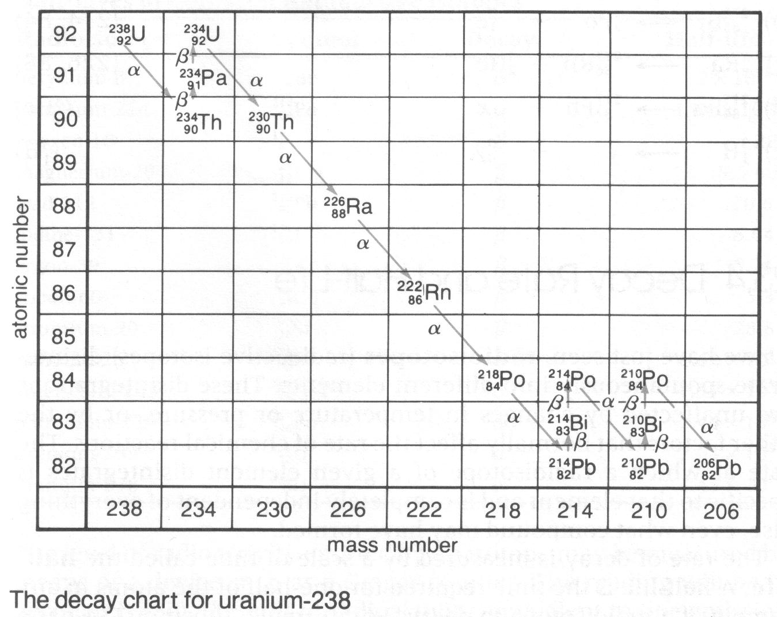

When a radioactive isotope undergoes decay the resulting isotope is often

radioactive as well. The series of nuclear reactions required to reach a stable non-radioactive isotope is referred to as a nuclear decay series. The series of reactions can be displayed on a nuclide chart like the one shown.

Write complete nuclear equations for the following:

A. The beta decay of thorium-234.

Atomic mass: 234 =0 + A

A = 234

Atomic number: 90 = Z + (-1)

Z = 91

(element 91 is Pa - protactinium)



Thus

*

B. The alpha decay of radium-226.

Atomic mass: 226 = 4 + A

A = 222

Atomic number: 88 = Z + 2

Z = 86

(element 86 is Rn - radon)



Thus



* – – involves more than just the emission of an electron. See below.

# Conservation laws applied to alpha decay

As we saw in Lesson 35, the old law of conservation of mass was incorporated into a broader and more effective law of conservation of energy when Einstein's mass-energy relationship (E = mc2) was included. We will now apply the mass-energy conservation law to the kinetic energies of the particles emitted by radioactive substances.

The energy of an alpha particle can be determined from the mass of the parent radioactive nucleus, the mass of the alpha particle, and the mass of the daughter nucleus. The alpha particle and the daughter nucleus together have a mass slightly smaller than that of the parent nucleus. The energy equivalence of the mass defect is, or should be, equal to the kinetic energy of the emitted alpha particle. In the decay of thorium-232, for example, an alpha particle is emitted and the final nucleus is radium-228. Without measuring the masses of the nuclei directly, one can predict, using conservation of energy, that when thorium-232 emits an alpha particle, the mass deficit should equal the kinetic energy of the alpha particle.



In theory, all the alpha particles emitted by thorium-232 should have the same kinetic energy and this prediction was verified in the 1920s. It was found that the alpha particles from thorium-232 could all penetrate 2.8 cm of air. In the case of polonium-212, the particles all penetrated 8.6 cm of air, while those from radium-222 penetrated 3.3 cm. Thus, since the pene­tration is directly related to the energy of the particle, the alpha particles from a specific radioactive source all have the same energy. (Actually, there were some irregularities in the alpha particle penetration. Later it was found that the original radioactive nucleus, like orbiting electrons, could exist in a number of excited states. When an alpha particle is emitted from an excited nucleus, the alpha particle carries away most of this energy. However, since the normal condition of the nucleus is to be in its ground state, the vast majority of emitted alpha particles have the same energy.)

# Conservation laws applied to beta decay

For alpha particles, the conservation of mass-energy worked very well, but this was not so for beta particles. If the same reasoning is applied to beta decay, the particles emitted from identical radioactive nuclei should each have the same energy and it was clear, as early as 1900, that this was not the case. In each beta decay there was a certain loss of mass, which should have been equivalent to the kinetic energy of the emitted beta particle, but it was found that the kinetic energy of the beta particle had a range of values.

According to the conservation of mass-energy, no beta particle should have a kinetic energy less than the energy equivalent of the mass decrease. And yet, beta particles were regularly given off with less kinetic energy than predicted. In fact, very few beta particles have the predicted maximum kinetic energy – on average, the most common value is 40% of the maximum. On the surface, it appeared that conservation of mass-energy failed for beta particle production. This was an alarming conclusion to the phy­sicists of the 1920s.

In 1931, Wolfgang Pauli suggested an explanation. He proposed that if the beta particle did not carry off all the available energy the remainder might be given to a second particle. But what would the properties of this mysterious second particle be? To begin with, it was understood that beta particles are produced when a neutron in the nucleus is converted into a proton.



To satisfy the conservation of electrical charge, Pauli's particle had to be neutral. Further, a charged particle would be easily detectable, and the new particle had not been observed. Neutral particles are very difficult to detect directly.

From a **conservation of mass-energy** perspective, when a neutron breaks down into a proton and an electron, the loss in mass is equivalent to approximately one-half the mass of an electron. In fact, Pauli's particle must have been considerably lighter, since the emitted electron usually gets some of the energy and sometimes all of it. As physicists recalculated their estimates of the mass of Pauli's particle, it became clear that it, like the photon, was a **massless particle** – it had a rest mass of zero.

Pauli's particle thus emerged as a neutral, massless particle. En­rico Fermi, the great Italian physicist, suggested that this particle be called the **neutrino**, which in Italian means "little neutral one". The neutrino is usually given the symbol , which is the Greek letter "nu". Now the equation for neutron decay can be written:



The neutrino, proposed by Pauli and supported by the subse­quent work of Fermi, received a mixed reception in the world of physics. To some it appeared to be a mythical particle created to save the law of conservation of energy, but this was not the only conservation law saved by the neutrino.

When a neutron is at rest, its momentum is zero. When it decays, the emitted electron will have momentum as will the re­coiling proton. According to the **conservation of momen­tum**, the electron should shoot off in one direction and the proton in exactly the opposite direction, but this is not what is observed. The electron and proton are both emitted at an angle, which, as we learned in Lesson 3, is not possible. The inclusion of a neutrino makes the net momentum of the system zero. Linear momentum is conserved.

p+

e–

•

■

•

Another conservation law to be considered is the **conservation of angular momentum**. Particles have energy and angular momentum because of their **spin**. Using the quantum scale of measurement, the proton and electron both have a spin of ½. Angular momentum can, however, exist in two variations, clockwise +½ and counter clockwise –½. The conservation of angular momentum requires that in a system containing a number of particles, the sum of the spins of the individual particles before the interaction must be equal to the sum of the spins of the individual particles after the interaction. Like the conservation of mass-energy and linear momentum, angular momentum cannot be conserved unless a neutrino is produced.

In summary, it appears that the neutrino is required in order to save no less than three conservation laws: mass-energy, linear momentum, and angular momentum. The strength of these arguments slowly convinced physicists that this mysterious, ghostlike particle must be there, even though it could not be detected. (Unlike charged particles like protons and electrons, neutral particles like neutrons and neutrinos are very difficult to observe directly. In fact, a neutrino could pass through lead that is one light year thick without interacting with the lead. In addition, if you look at your thumb nail, 60 billion neutrinos pass through it from the Sun every second.) Twenty five years after Pauli theorised their existence, the neutrino was experimentally verified. In 1956 a particle with zero rest mass, travelling at the speed of light (like a photon), with linear mo­mentum, and a spin of ½ was observed.

More recently (1986), it has been determined that the neutrino’s mass (if it has mass) is less than a mere 27 eV/c2 (about 19000 times less than an electron). The issue of a nonzero neutrino mass is crucial in astrophysics. Even if the neutrino corresponded to just a few eV/c2, they are so numerous that much of the mass of the Universe would be invisible neutrinos. That hidden mass might well determine the fate of the entire Universe.

[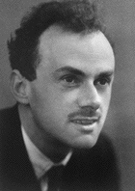](http://en.wikipedia.org/wiki/Image:Dirac.gif)But our story of the neutrino does not end here, there was one more twist. In 1928 Paul Dirac developed a relativistic equation for the electron, now known as the Dirac equation. It was immediately clear to Dirac that his equation had two kinds of solutions. One set of solutions offered a correct and consistent description of how an electron should behave in an electromagnetic field, including the newly discovered phenomenon of electron spin. Curiously, the equation was found to have negative-energy solutions in addition to the normal positive ones. Dirac initially tried to ignore the negative solution as a mathematical irregularity, but after a time he realised that it could not be ignored. By 1931 Dirac proposed the existence of an **antielectron**, a particle with the same mass as an electron but with opposite charge. A year later Carl Anderson, working with Millikan, was studying cosmic-rays which stream in on Earth from space. The cosmic-rays were observed using a cloud chamber inside a uniform magnetic field so that positive and negative charges would follow opposite curved paths. Among the thousands of photographs taken, Anderson noticed one with two oppositely curved, mirror image tracks. One was certainly an electron, while the other suggested an antielectron. By the end of the summer of 1932, Anderson had clear evidence of the existence of the antielectron which he named the **positron**.

It took Dirac a few years to comprehend that the mathematics of his equation demanded the existence of antimatter. This led him to remark that the equation was more intelligent than its author. Today's Standard Model (see Lesson 37) shows that every particle (electron, proton, neutron, etc.) has an antiparticle (positron, antiproton, antineutron, etc.). The same is true for neutrinos. There are neutrinos () and antineutrinos (). (The bar above a symbol signifies an antiparticle.)

The result is that we have two types of beta decay:

**– decay** involves the transformation of a **neutron into a proton and an electron which also produces an antineutrino**



– decays involving the nucleus of an atom have the general form



**+ decay** involves the transformation of a **proton into a neutron and a positron which also produces a neutrino**



+ decays involving the nucleus of an atom have the general form



Write complete nuclear equations for the following:

A. The – decay of actinium-230.

Atomic mass: 230 =0 + A

A = 230

Atomic number: 89 = Z + (-1)

Z = 90

(element 90 is Th - thorium)



Thus



B. The + decay of neptunium-234.

Atomic mass: 234 =0 + A

A = 234

Atomic number: 93 = Z + (+1)

Z = 92

(element 92 is U - uranium)



Thus



**Note**: Much of this section on “Conservation laws applied to beta decay” goes beyond the Physics 30 curriculum. While I believe it is important for you to understand why the idea of a neutrino was proposed and subsequently observed, this will not be tested in the Physics 30 course. You are required to understand – decay and + decay in terms ofpredicting parent and daughter isotopes and writing proper decay equations.

# Gamma radiation

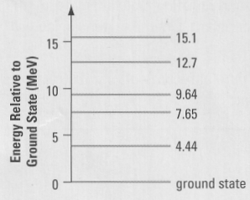Like the excitation of atoms discussed in Lessons 30 and 31, nuclei also have a series of excitation energy levels. In the excited states the nucleons are farther apart. As a result, their binding energy is greater than when in the ground state, and the total energy of the nucleus is greater. When making a transition to a lower-energy state, a nucleus emits a gamma-ray photon, similar to the photon emitted when an electron in an atom moves to a lower energy level. However, the difference in energy is much greater for a nucleus – note that the energy scale is in MeV. Gamma decay does not change either the atomic number or the atomic mass.

Often, an alpha or beta decay leaves the daughter nucleus in a highly excited state. The excited nucleus then makes a transition to its ground state and emits a gamma ray. For example, when the  decay of boron-12 produces carbon-12, the carbon nucleus is highly excited (represented by a *) and quickly emits a gamma ray:



The energy of a gamma ray depends on the energy levels and the degree of excitation of the particular nucleus. Gamma rays can have energies ranging from thousands to millions of electron volts.

# Biological effects of ionizing radiation

It is **required** that in addition you read Pearson pages 808 and 809.

Ionizing radiation consists of photons and/or moving particles that have sufficient energy to knock an electron out of an atom or molecule, thus forming an ion. The photons usually lie in the ultraviolet, x-ray, or -ray regions of the electromagnetic spectrum, while the moving particles can be the  and  particles emitted during radioactive decay. An energy of roughly 10 to 35 eV is needed to ionize an atom or molecule, and the particles and -rays emitted during nuclear disintegration often have energies of several million eV. Therefore, a single  particle,  particle, or -ray can ionize thousands of molecules. The effect of radiation on living organisms depends on the energy it carries, its ability to ionize atoms and molecules, and the depth to which it can penetrate living tissue. The charge and energy of the radiation determine how ionizing it is. The energy also affects how far the radiation can penetrate.

Nuclear radiation is potentially harmful to humans because the ionization it pro­duces can significantly alter the structure of molecules within a living cell. The al­terations can lead to the death of the cell and even the organism itself. Despite the potential hazards, ionizing radiation is used in medicine for diagnostic and therapeutic purposes, such as locating bone fractures and treating cancer. The hazards can be minimized only if the fundamentals of radiation exposure, including dose units and the biological effects of radiation, are understood.

|  |  |  |  |
| --- | --- | --- | --- |
| Radiation Hazards from Natural Sources Outside the Body | | | |
| **Radiation** | **Typical Penetration** | **Ionization** | **Hazard** |
| alpha | Travels about 5 cm in air.  Cannot penetrate skin. | high | low |
| beta | Travels about 30-50 cm in air.  Penetrates about 1 cm into the body. | moderate | low |
| gamma | Travels great distances in air.  Penetrates right through the body. | low | high |

Although  and  particles are much less penetrating than gamma radiation, they can still be extremely harmful if emitted by material absorbed into the body, because the nearby tissue has a continuing exposure to the radiation. For example, health scientists have calculated that breathing in a speck of dust containing just 1 µg of plutonium is virtually certain to cause lung cancer within 30 years.

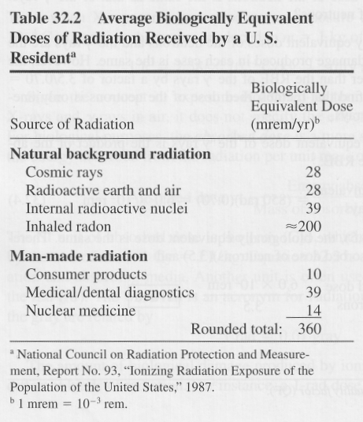Everyone is continually exposed to background radiation from natural sources, such as cosmic rays (high-energy particles that come from outside the solar system), radioactive materials in the environment, radioactive nuclei (primarily carbon  and potassium ) within our own bodies, and radon. The table to the right lists the average biologically equivalent doses received from these sources by a person in the United States. According to this table, radon is a major contributor to the natural background radiation. Radon is an odourless radioactive gas and poses a health hazard because, when inhaled, it can damage the lungs and cause cancer. Radon is found in soil and rocks and enters houses through cracks and crevices in the foundation. The amount of radon in the soil varies greatly throughout the country, with some localities having significant amounts and others having virtually none. Accordingly, the dose that any individual receives can vary widely from the average value of 200 mrem/yr. In many houses, the entry of radon can be reduced significantly by sealing the foundation against entry of the gas and providing good ventilation so it does not accumulate. To the natural background of radiation, a significant amount of man-made radiation has been added, mostly from medical/dental diagnostic x-rays.

The effects of radiation on humans can be grouped into two categories, according to the time span between initial exposure and the appearance of physiological symptoms: (1) short-term or acute effects that appear within a matter of minutes, days, or weeks, and (2) long-term or latent effects that appear years, decades, or even generations later. Radiation sickness is the general term applied to the acute effects of radiation. Depending on the severity of the dose, a person with radiation sickness can exhibit nausea, vomiting, fever, diarrhea, and loss of hair. Ultimately, death can occur. The severity of radiation sickness is related to the dose received.

# Decay rate and half-life

Radioactive elements do not decay all at once. Their decay rate is governed by a logarithmic or exponential equation:



where N number of radioactive nuclei remaining

or mass remaining

or activity of the material

No original number of radioactive nuclei

or original mass

or original activity of the material

n number of half lives*



*A half-life (t1/2) is the time it takes for ½ of the parent isotope to decay into the daughter isotope or the time it takes for the radioactivity level to decrease by ½. Half-lives can range from a few trillionths of a second to trillions of years depending on the stability of the isotope.

daughter

parent

parent 100%

daughter 0%



parent 50%

daughter 50%



parent 25%

daughter 75%



parent 12.5%

daughter 87.5%

The half-life of a radioactive isotope is 2.5 years. If the activity of the original sample of this isotope was 3.2 x 103 Bq, what is its activity after 5 years.





A 2.0 gram sample of a radioactive isotope undergoes radioactive decay. If the half life of the isotope is 45 minutes, how much of this isotope remains after 5.0 hours?





If the activity of a radioactive sample of Q is 28 Bq and 8.0 hours later its activity is 7 Bq, what is the half life of Q?



We can also use decay curves to determine the half-life of an element. When a set of data is given, one can graph the results and then determine the half-life. To determine the half-life off a decay curve, find an interval on the vertical axis where the mass or decay rate is decreased by ½. The half-life is the **time** (horizontal axis) for that interval.

•

•

•

•

Number of parent nuclei remaining



Time



# Practice problems

1. Write the equation for the alpha decay of plutonium-244.

2. Write the equation for the beta-negative decay of oxygen-19.

3. Write the equation for the beta-positive decay of fluorine-17.

4. The following data was collected for the decay rate of technetium-104. What is the half-life of technetium-104?

|  |  |  |  |  |  |  |  |  |
| --- | --- | --- | --- | --- | --- | --- | --- | --- |
| time (min) | 0 | 10 | 20 | 30 | 40 | 50 | 60 | 70 |
| decay rate (counts/s)  decay rate  Time (min)  80  70  60  50  40  30  20  10  0  0  20  40  60  80  100 | 80 | 54 | 37 | 25 | 17 | 12 | 8 | 5 |

# Hand-in assignment

1. How many protons and neutrons are there in the nucleus of(a) oxygen-16 and

(b) tin-120. Write the isotope symbol for each of the above elements.

2. Write an equation to show the beta-negative decay of phosphorous-34.

3. In each of the following equations, determine the emitted particle(s) in each case.

a.  e. 

b.  f. 

c.  g. 

d.  h. 

4. Radium-226 decays to polonium-214 as follows:

(a) (b) (c) (d) (e)



What kind of particle is emitted in each of the transmutations labeled (a) to (e).

5. The half-life of a certain radioactive isotope is 20 h. How much of an original

320 g sample will remain the same radioactive isotope after (a) 40 h? (b) 80 h?

(c) 5 days? (80 g, 20 g, 5 g)

6. An experiment was performed to determine the half-life of technetium-99. The activity was measured and the results are recorded below.

|  |  |  |  |  |  |  |  |  |  |
| --- | --- | --- | --- | --- | --- | --- | --- | --- | --- |
| Time (h) | 0 | 3 | 6 | 9 | 12 | 15 | 18 | 21 | 24 |
| Activity  (kBq) | 17.0 | 12.2 | 8.9 | 6.5 | 4.5 | 3.2 | 2.3 | 1.5 | 1.1 |

A. Plot a graph of activity versus time.

B. Using the graph, determine the half-life of technetium-99.

C. Predict the activities for the following times:

(i) 7 h (ii) 19 h (iii) 26 h

7. A radioactive sample was monitored for radiation with the following results:

|  |  |  |  |  |  |  |  |  |  |  |
| --- | --- | --- | --- | --- | --- | --- | --- | --- | --- | --- |
| Time (s) | 0 | 30 | 60 | 90 | 120 | 150 | 180 | 210 | 240 | 270 |
| Activity  (counts/s) | 32 | 25 | 20 | 15 | 12 | 10 | 8 | 6 | 4 | 3 |

A. Plot an activity - time graph on graph paper.

B. Estimate the half-life for this sample. Explain your method.

8. Strontium-82 has a half-life of 25.0 d. If you begin with a sample having a mass of 140 g, in how many days will you have only 17.5 g of strontium-82 left? (75.0 days)

9. The average natural radioactivity of 1 m3 of radon gas is 10 emissions per second, or 10 Bq. If the half-life of radon gas is 4 d, how long will it take for 1 m3 of radon gas to reach an average radioactivity of 2.5 Bq? (8.0 days)

10. In 9.0 days the number of radioactive nuclei decreases to one-eighth the number initially present. What is the half-life (in days) of the material? (3.0 days)

11. When uranium-235 is bombarded by a neutron, the fission products include zirconium-96, three free neutrons, and another daughter isotope. Write an equation to show this nuclear reaction and the identity of the other daughter isotope.

12. Find the energy in MeV released when alpha decay converts thorium-228 (228.028715 u) into radium-224 (224.020186 u). The mass of an alpha particle is 4.002603 u. (–4.86 MeV)